Edrin S(192524041)
Query Processing (DSA0504)
UNIT 2 ACTIVITY 1:
01_create_database and create_table and insert_record
Code:
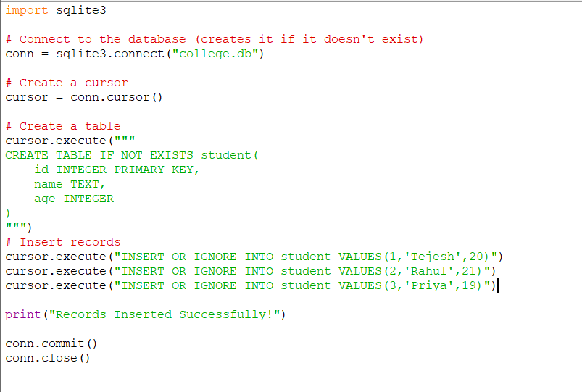
Output:
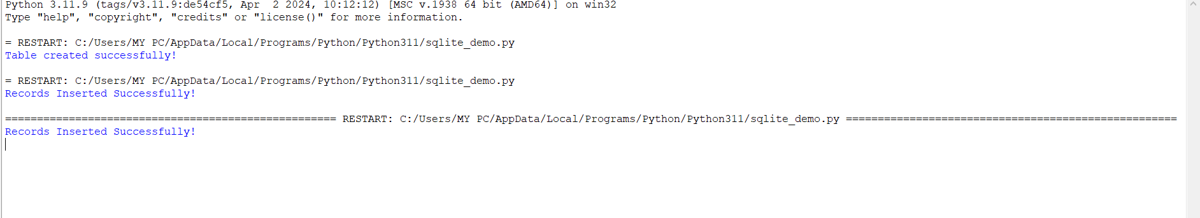
02_select_all
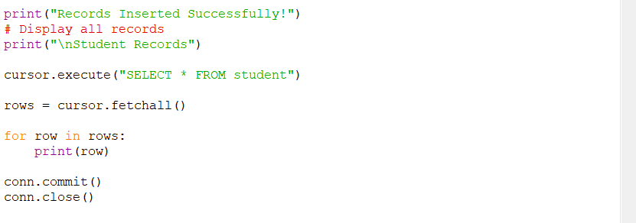
Output:
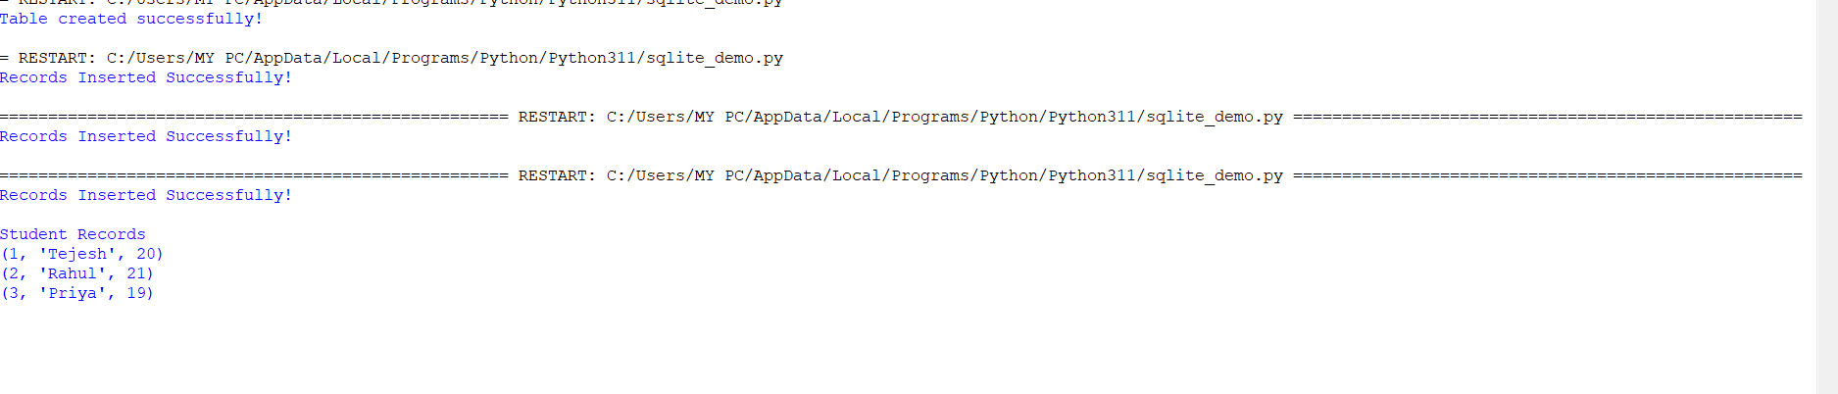
03_select_one
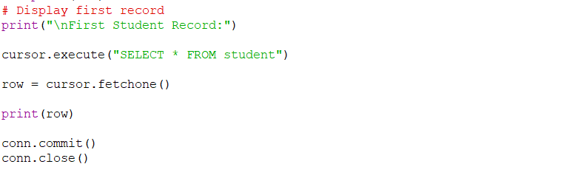
Output:
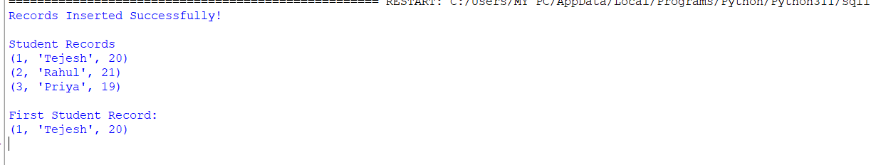

04_WHERE Clause
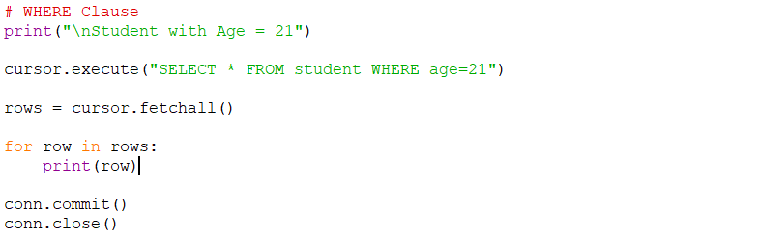
Output:
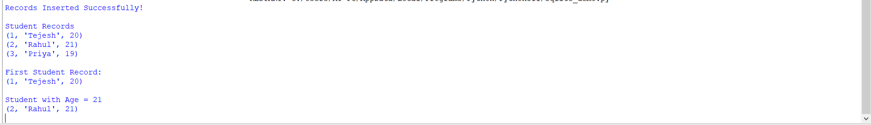

05_ORDER BY
Code:
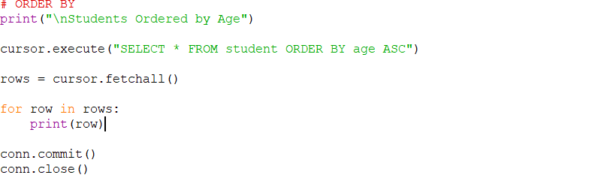
Output:
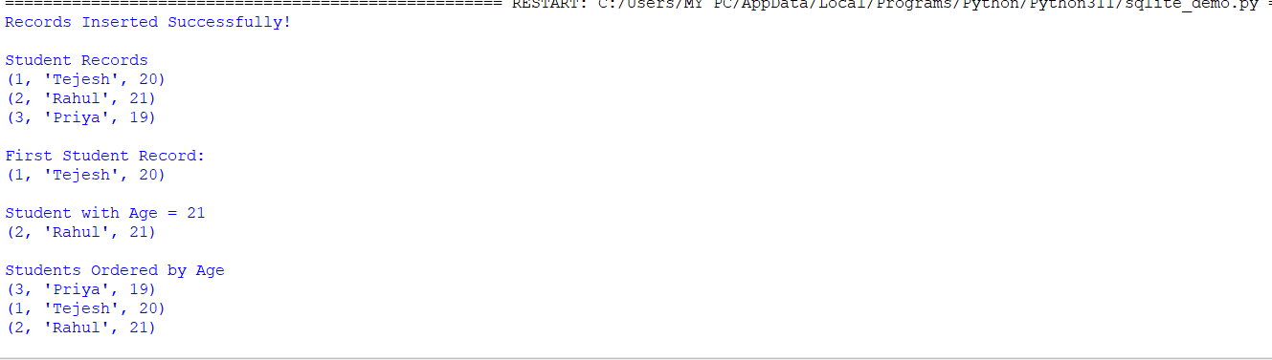

06_UPDATE Record
Code:
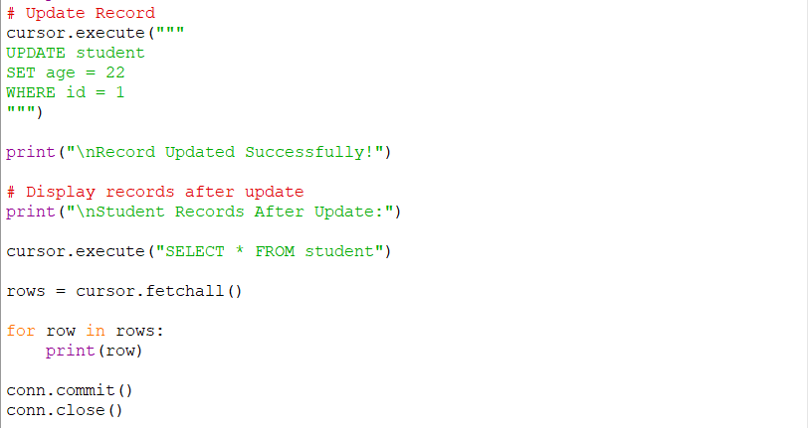
Output:
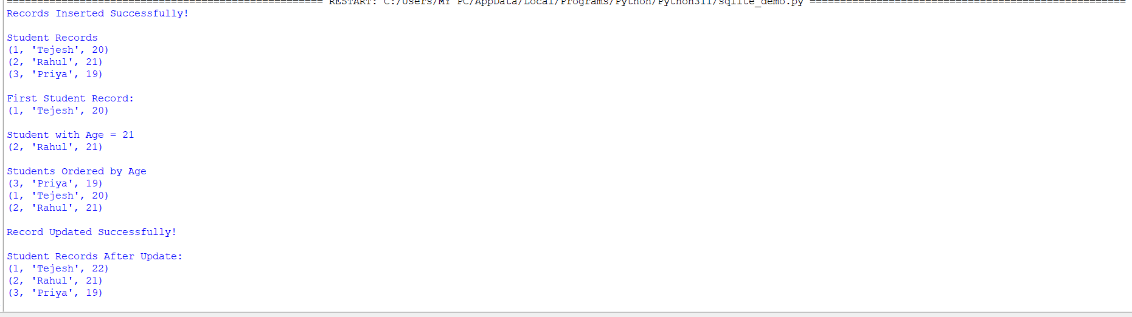
07_DELETE Record
code:
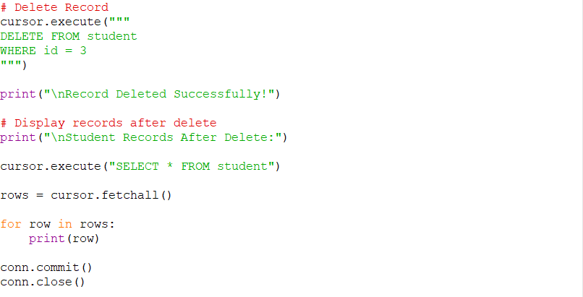
Output:
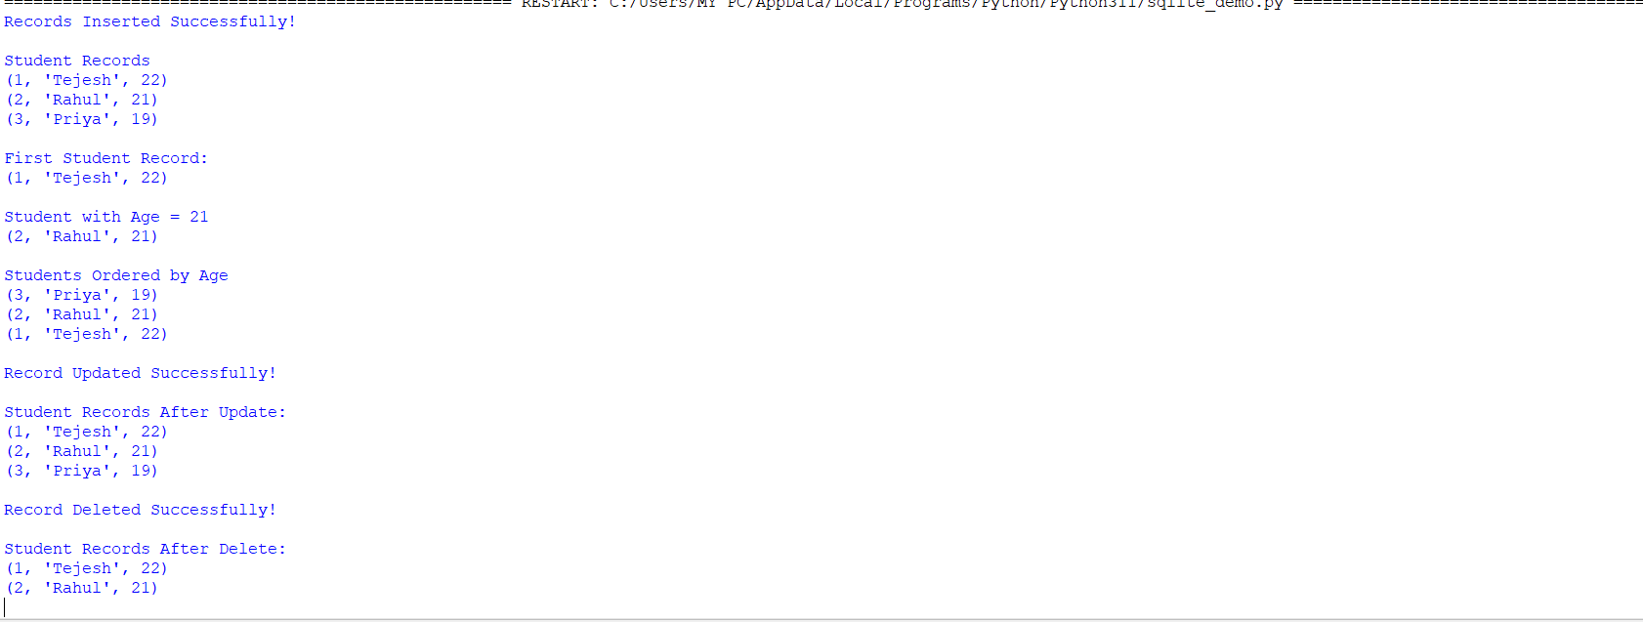

08_DROP TABLE
code:
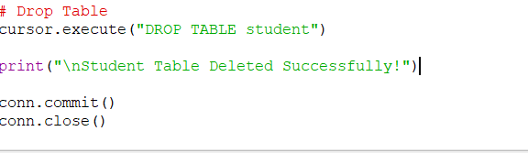
Output:
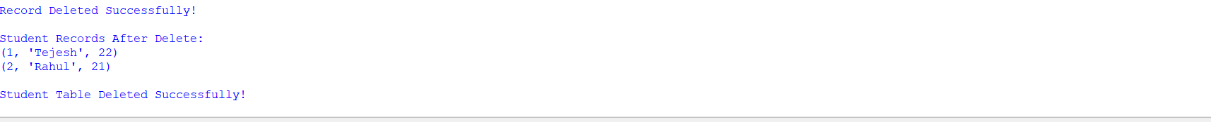
Overall code :
import sqlite3

# Connect to the database (creates it if it doesn't exist)
conn = sqlite3.connect("college.db")

# Create a cursor
cursor = conn.cursor()

# Create a table
cursor.execute("""
CREATE TABLE IF NOT EXISTS student(
id INTEGER PRIMARY KEY,
name TEXT,
age INTEGER
)
""")
# Insert records
cursor.execute("INSERT OR IGNORE INTO student VALUES(1,'Tejesh',20)")
cursor.execute("INSERT OR IGNORE INTO student VALUES(2,'Rahul',21)")
cursor.execute("INSERT OR IGNORE INTO student VALUES(3,'Priya',19)")

print("Records Inserted Successfully!")
# Display all records
print("\nStudent Records")

cursor.execute("SELECT * FROM student")

rows = cursor.fetchall()

for row in rows:
print(row)
# Display first record
print("\nFirst Student Record:")

cursor.execute("SELECT * FROM student")

row = cursor.fetchone()

print(row)
# WHERE Clause
print("\nStudent with Age = 21")

cursor.execute("SELECT * FROM student WHERE age=21")

rows = cursor.fetchall()

for row in rows:
print(row)
# ORDER BY
print("\nStudents Ordered by Age")

cursor.execute("SELECT * FROM student ORDER BY age ASC")

rows = cursor.fetchall()

for row in rows:
print(row)
# Update Record
cursor.execute("""
UPDATE student
SET age = 22
WHERE id = 1
""")

print("\nRecord Updated Successfully!")

# Display records after update
print("\nStudent Records After Update:")

cursor.execute("SELECT * FROM student")

rows = cursor.fetchall()

for row in rows:
print(row)
# Delete Record
cursor.execute("""
DELETE FROM student
WHERE id = 3
""")

print("\nRecord Deleted Successfully!")

# Display records after delete
print("\nStudent Records After Delete:")

cursor.execute("SELECT * FROM student")

rows = cursor.fetchall()

for row in rows:
print(row)
# Drop Table
cursor.execute("DROP TABLE student")

print("\nStudent Table Deleted Successfully!")

conn.commit()
conn.close()

overall output:
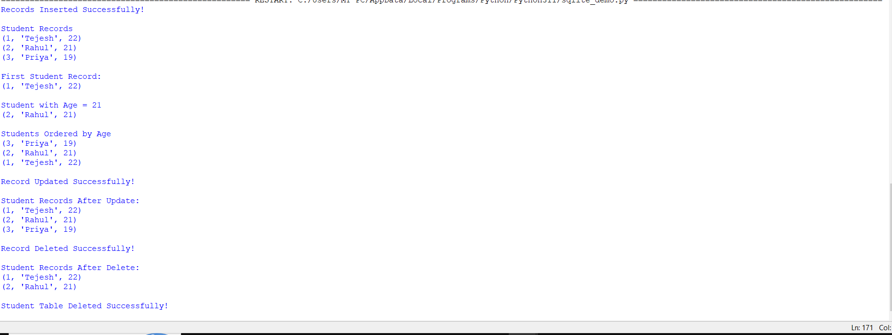

Student Skill Tracker application:
Codes:
from flask import Flask, render_template, request, redirect
import sqlite3

app = Flask(__name__)

# Create Database and Table
def create_table():
conn = sqlite3.connect("student_skill.db")
cur = conn.cursor()

cur.execute("""
CREATE TABLE IF NOT EXISTS students(
id INTEGER PRIMARY KEY AUTOINCREMENT,
name TEXT,
department TEXT,
skill TEXT,
level TEXT
)
""")

conn.commit()
conn.close()

create_table()

@app.route("/")
def home():

conn = sqlite3.connect("student_skill.db")
cur = conn.cursor()

cur.execute("SELECT * FROM students")
students = cur.fetchall()

conn.close()

return render_template("index.html", students=students)

@app.route("/add", methods=["POST"])
def add():

name = request.form["name"]
department = request.form["department"]
skill = request.form["skill"]
level = request.form["level"]

conn = sqlite3.connect("student_skill.db")
cur = conn.cursor()

cur.execute(
"INSERT INTO students(name,department,skill,level) VALUES(?,?,?,?)",
(name, department, skill, level)
)

conn.commit()
conn.close()

return redirect("/")

@app.route("/delete/<int:id>")
def delete(id):

conn = sqlite3.connect("student_skill.db")
cur = conn.cursor()

cur.execute("DELETE FROM students WHERE id=?", (id,))

conn.commit()
conn.close()

return redirect("/")

@app.route("/search", methods=["POST"])
def search():

skill = request.form["skill"]

conn = sqlite3.connect("student_skill.db")
cur = conn.cursor()

cur.execute("SELECT * FROM students WHERE skill=?", (skill,))
students = cur.fetchall()

conn.close()

return render_template("index.html", students=students)

if __name__ == "__main__":
app.run(debug=True)

html:
<!DOCTYPE html>
<html>
<head>

<title>Student Skill Tracker</title>

<style>

body{
font-family:Arial;
background:#f2f2f2;
}

.container{
width:900px;
margin:auto;
background:white;
padding:20px;
margin-top:30px;
border-radius:10px;
box-shadow:0 0 10px gray;
}

h1{
text-align:center;
color:blue;
}

input{
padding:8px;
margin:5px;
width:170px;
}

button{
padding:8px 15px;
background:blue;
color:white;
border:none;
cursor:pointer;
}

table{
width:100%;
margin-top:20px;
border-collapse:collapse;
}

table,th,td{
border:1px solid gray;
}

th{
background:blue;
color:white;
padding:10px;
}

td{
padding:10px;
text-align:center;
}

a{
color:red;
text-decoration:none;
font-weight:bold;
}

</style>

</head>

<body>

<div class="container">

<h1>Student Skill Tracker</h1>

<form action="/add" method="post">

<input type="text" name="name" placeholder="Student Name" required>

<input type="text" name="department" placeholder="Department" required>

<input type="text" name="skill" placeholder="Skill" required>

<input type="text" name="level" placeholder="Level" required>

<button>Add Student</button>

</form>

<br>

<form action="/search" method="post">

<input type="text" name="skill" placeholder="Search Skill">

<button>Search</button>

</form>

<table>

<tr>

<th>ID</th>
<th>Name</th>
<th>Department</th>
<th>Skill</th>
<th>Level</th>
<th>Delete</th>

</tr>

{% for s in students %}

<tr>

<td>{{s[0]}}</td>

<td>{{s[1]}}</td>

<td>{{s[2]}}</td>

<td>{{s[3]}}</td>

<td>{{s[4]}}</td>

<td>

<a href="/delete/{{s[0]}}">Delete</a>

</td>

</tr>

{% endfor %}

</table>

</div>

</body>
</html>

Output:
